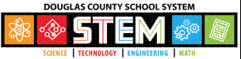
.
.

2018-19
DCSS STEM Fair

Handbook
Guidelines

Table of Contents

DCSS Stem Fair Details/STEM competitions 3
Science, Engineering, and Computer Science Project Info 4-5
Logbook guidelines and rules 6
How to Choose your project 7
Online Resources to help with projects 8
Safety Regulation, Rules, and Need for SRC review explained 9
Project Proposal Form before you begin experimentation 10a
Sample Response from SRC/IRB to a project proposal 10b
One suggested timeline besides our DCSS timeline 10c
Scientific Investigation Project details 11-14
Engineering Project details 15-17
Computer Science Project details 18-20
Display and Safety Rules 21-22
How Adults can help 23

End of Document
- Science Rubric Descriptors
- Engineering Rubric Descriptors

What is the DCSS STEM Science Fair?
Welcome, Students!

The STEM Fair is a celebration of YOU and of your learning in Science, Technology, Engineering, and Mathematics (STEM). It is the place to share what you care deeply about and to show the community how STEM can be used to impact our future. To join the event, you may use work done with a partner or work you’ve developed independently with support from a teacher, mentor or coach.

A Quick Note about STEM Competitions

In addition to the DCSS STEM Fair here are a few other STEM competitions that you might like to participate in to share your ideas. Find an event that fits your style. Be sure to follow all instructions given for your other STEM event/competition very carefully. Also, consider reviewing these events for great ideas to help you with your DCSS STEM Science Fair project.
- UWGA Science & Engineering Fair
- UGA Science & Engineering Fair
- Intel International Science & Engineering Fair
- Broadcom MASTERS
- DuPont Challenge
- Google Science Fair
- Siemens Competition
- eCybermission
- FIRST LEGO League

Besides using your ideas to make a difference in the world, here are a few other reasons to consider participating in a STEM competition:
- You can start to make a difference in the world now! (Just had to mention that one more time.) It’s really the most important reason for doing science and engineering, after all.
- You have something to brag about on your college applications.
- You have something significant to add to your resume.
- You can make great connections with the scientific and engineering community.
- $$$ All competitions listed above have cash prizes. $$$
- $$$ Some of the competitions listed above have scholarship prizes. $$$

Categories of projects at the STEM Fair

Science investigations focuses on research and producing knowledge about the world. Science investigations involve applying the scientific method to a question that could be answered by planning and completing an experiment.

Engineering design and invention focuses on the design and production of a physical product used to solve a problem. These types of projects are accepted at the Shoreline STEM Science Fair but may not be allowed at other STEM competitions.

Computer Science design and invention These projects focus on the design and production of software or computer hardware to solve a problem. These types of projects are accepted at our STEM Science Fair but may not be allowed at other STEM competitions. They are assessed at our county fair with the Engineering rubric as well.

The boundaries between science investigations, engineering, and computer sciences are not always clear. Your project may fall in the gray area between these categories, and that’s OK. Some topics in engineering and computer science are best addressed as a science investigation. Review the information in this handbook to see which seem to best suit your interest.

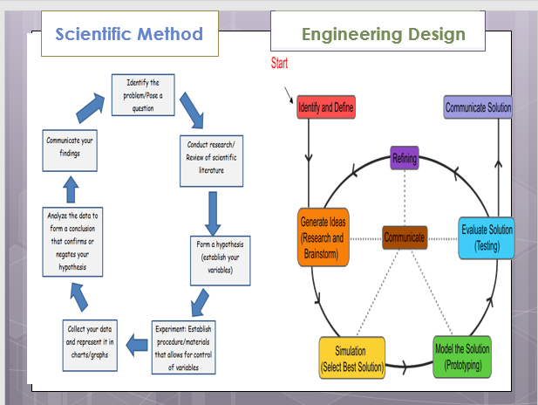

Steps of the Scientific method or design process

If your project is a science investigation you will apply the scientific method to help answer a question or hypothesis.

The steps of the scientific method are to:
Ask a Question
Do Background Research Construct a Hypothesis
Test Your Hypothesis by Doing an Experiment Analyze Your Data and Draw a Conclusion Communicate Your Results

If your project is an engineering or computer science design and invention you will follow the design process to help produce a new product to solve a problem.

The steps of the design process are to:
Define the Problem
Do Background Research Specify Requirements Brainstorm Solutions Choose the Best Solution Do Development Work Build a Prototype
Test and Redesign

The design process does not need to follow these steps in order, one after another. It is very common to design something, test it, find a problem, and then go back to an earlier step to make a modification or change to your design. This way of working is called iteration.

Additional Guidance

For more resources understanding the steps of the scientific method or design process check out the Sciencebuddies.org Science Fair project guide or Engineering project guide: (http://www.sciencebuddies.org/science-fair-projects/project_guide_index.shtml)

Research Logbook Guidelines

Logbooks are required for entry into the DCSS STEM Fair but are encouraged to help organize your ideas and document progress on your project. Notebooks may also be required for other STEM competitions. Your project notebook is the most important aspect of providing evidence that your ideas and work belong to you. It is a detailed account of every phase of your project, from your initial ideas to your final products. It is a hand-written, day-by-day record of everything related to your project.

General Guidelines:
- Use a durable, stitched, laboratory-type notebook. Pages are not to be removed.
- Use the first few pages as your Table of Contents and fill in titles and pages as you work.
- Begin using the notebook right away and document everything you do for the project.
- Whether working individually or as a team, each person must have a notebook.
- All pages must be numbered before information is entered.
- All pages are dated as information is added.
- All entries should be done in blue or black ink. No pencil.
- Don’t worry about neatness. This is a real, working notebook that serves as a “diary” or record of what you are doing. Don’t re-write pages to make them look nice. They only have to be legible and organized enough for others to read your work and understand what you are doing.
- Simply put a line through errors – no white-out – and initial.
- Most of the records in your lab notebook will be hand-written.
- Notebooks typically include:
  - Topic ideas and brainstorming, questions about your topic
  - Daily observations and ideas
  - Question (or hypothesis) for your investigation
  - Literature review reading notes, bibliographical citations
  - Drafts of materials and procedures, and actual materials and procedures
  - Labeled sketches and photos of experimentation
  - Data tables, calculations, graphs
  - Data analysis notes, conclusion notes
  - Poster design

Choosing Your Project Topic

Choosing your Project Topic is the first step and probably one of the more difficult things about doing a STEM project. The following suggestions can help you get started:

Generate a list of interests: The best topic comes from something you are passionate about. What are your hobbies? Are you interested in how things work, patterns you observe in nature, solving a problem or issue you have noticed in your community? Is there something you have always wondered about? Is there a product or design you have wanted to develop or improve?

Get help: Brainstorm ideas with a friend, parent, or another interested adult. Email or call local scientists focused on your topic to ask if they have simple project suggestions. Many will be excited to know you are interested!

What questions do I have about the topic? Just as you identified a topic, generate a list of questions you have about this topic. Remember, this is all a brainstorm to this point

What is the purpose of my experiment? While thinking about your topic consider why it would be important to know more about your topic.

Some additional guidelines:

Be sure that your STEM Fair project represents your work

If you go online to get project ideas remember that you are not trying to copy an experiment to get the result you see online. You can use it for research and guess of what might happen if you do the experiment. Follow instructions and only report your findings.

A research project may be a part of a larger study performed by professional scientists or projects may be collaborations with professional scientists, but the project you present must represent only your own work.

Some projects are multiyear but only the current year’s research work can be presented at the STEM Science Fair.

Many projects can be done within the scope of your home and within a reasonable budget.

Online STEM resources

Sources for science fair project ideas

Science Buddies:
This site has project ideas and helpful topic selection wizard (K-12) http://www.sciencebuddies.org/science-fair-projects/project_ideas.shtml

Education.com:
Provides science fair project ideas by grade level (K-12) http://www.education.com/science-fair/:

Scienceproject.com:
Provides science fair project ideas by grade level (K-12) http://scienceproject.com/

40-cool-science-experiments-web (scholastic.com): Provides science fair project ideas (K-8)
http://www.scholastic.com/teachers/article/40-cool-science-experiments-web

Tools to aid in brainstorming a topic

Google Science Fair – Make a Better Generator:
An idea generator which will present related articles and links based on your responses to three questions. https://www.googlesciencefair.com/make-better-generator/en/

The DuPont Challenge:
They use a thematic approach to choosing a topic based on four categories that revolve around four prompts. http://thechallenge.dupont.com/

Sources for more complex science fair projects and additional project guidelines:

NASA Jet Propulsion Laboratory, How to Do a Science Fair Project: Six videos that explain “How to do a science fair project”
http://www.jpl.nasa.gov/edu/teach/activity/how-to-do-a-science-fair-project/

eCybermission:
You can watch series of short videos that guide students through each stage of a science or engineering process. https://www.ecybermission.com/WebinarsVideos

Science Buddies:
Also has nice project guidelines explaining the steps of the scientific method and engineering process. http://www.sciencebuddies.org/science-fair-projects/project_guide_index.shtml

Discovery Education – Science Fair Central:
Provides a clear pathway to develop and present successful projects http://school.discoveryeducation.com/sciencefaircentral/Getting-Started.html

Toshiba ExploraVision:
This site has a series of great tips to help guide you through the processes of brainstorming, choosing a topic, and even how to research.
http://www.exploravision.org/how-brainstorm

Safety Regulations


The International Rules for Pre-college Science Research: Guidelines for Science and Engineering Fairs (ISEF) is published each year to support students doing independent research safely. They are the official rules of the Intel International Science & Engineering Fair as well as the DCSS STEM Science Fair.
ISEF Site: https://student.societyforscience.org/international-rules-pre-college-science-research

Rule book and forms can be found at: https://sspcdn.blob.core.windows.net/files/Documents/SEP/ISEF/2019/Rules/Book.pdf

Electronically Fillable forms are located at: https://sspcdn.blob.core.windows.net/files/Documents/SEP/ISEF/2019/Forms/All.pdf

The purpose of these rules is to:
- protect the rights and welfare of the student researcher and of the human participant
- to make sure federal regulations are followed and safe engineering and lab practices are used
- protect the environment
- determine eligibility for participation in the STEM Science Fair and other STEM competitions and events

To help us determine if your proposal meets the basic safety guidelines, please consider the following question:

Do you plan to use any of the following in your project for the DCSS STEM Science Fair?
  - Human Subjects (including yourself), in any way, even for surveys or opinions
  - Vertebrate Animals (animals with a backbone)- even your pet
  - Animal Tissues
  - Microorganisms (bacteria, fungi, viruses)
  - DNA
  - Disease causing agents
  - Radiation
  - Controlled or Hazardous Substances
  - Explosives
  - Chemicals not generally found in the household

YES NO

- Submit your project proposal to your teacher and indicate that safety review is required. She/He will send it to the SRC/
IRB for review. Pamela.walker@dcssga.org
They will follow up with details.

- Submit your project proposal to
your teacher for her approval only

If you answered YES to any question above, DO NOT BEGIN your project without prior approval from the STEM Safety Review Team (SRC/IRB) . Fill out the project proposal form and give it to the teacher. The form is found on the next page.

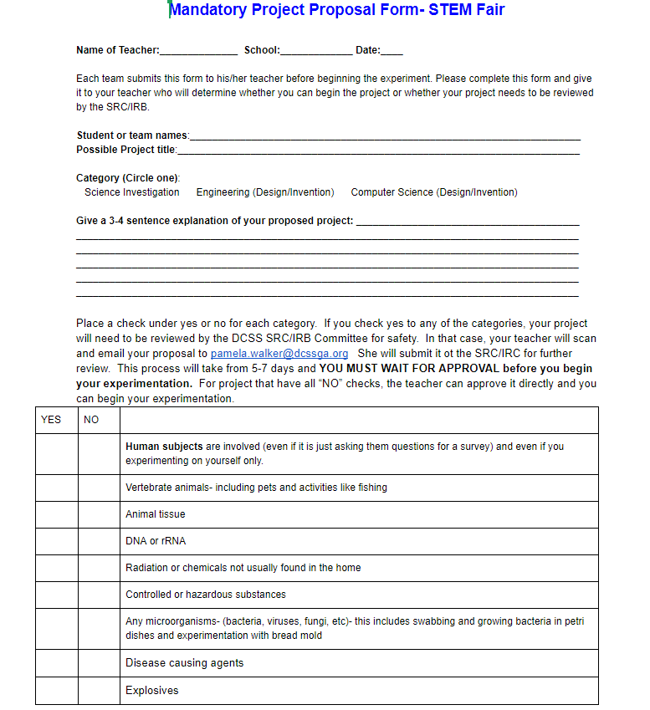
10a0

When can you expect a response from the SRC/IRC????

If your project has to go to the SRC/IRC for review, you will receive correspondence back within 5-7 days or less. The response will be in the format that follows:

Project Planning Proposal, Response from DCSS STEM

Proposal Review by DCSS STEM Safety Review Team (SRC): ____________(Date)

Congratulations! Your project proposal has been approved. Be sure you fill out all of the required forms for your project, making sure that you get the correct dates and signatures on the forms.

Signature of SRC/IRB Chair: ____________________________

Your project proposal isn’t ready for approval yet because: __________________________________________________________________
____________________________________________________________________________________________________________________________________
____________________________________________________________________________________________________________________________________

Please address these issues and re-submit your proposal or select a different project.

NOTE: If your project idea requires a consultation with the STEM Science Fair Safety Review Team, it doesn’t necessarily mean that you won’t be able to do your project. We will work with you to ensure that all safety regulations are followed.

10 b bbb0

Suggested Project Timeline/Calendar
Science investigations, computer science, and engineering projects take time. It’s not unusual for most of the time to be spent on background research and planning. Creating a timeline for your project is HIGHLY recommended. It helps to keep you on track and breaks the process into smaller tasks.

Here’s one example of a timeline you can use. There is a specific one for this year also posted.

 | Tasks to be completed in each week or two week time frame
Week 1 | - Decide whether to do a team or an individual project  - Brainstorm 3 topic ideas  - Develop at least 3 research questions or define at least 3 problems, share with an adult  - Think about how you would test each research question, or develop a solution for each problem  - Decide on a project category for the STEM fair and choose a testable research question, engineering design plan, or computer science design plan
Weeks 2&3 | - Make a list of questions you have about your topic  - Spend as much time as possible reading & taking notes on your topic  - Develop your scientific question or computer science/engineering design criteria  - Finalize your scientific question or computer science/engineering design criteria  - Complete a Project Planning Proposal form. One can be found on the next page of the handbook. Give it to your teacher who will either approve it or send it on to the SRC/IRB. Pamela.walker@dcssga.org
Weeks 4&5 | - Make a rough draft of your materials and research procedures or design plans  - If your plans involve human subjects (even if it’s just to ask them questions for a survey), animals or animal tissue, micro-organisms, DNA, radiation, controlled or hazardous substances, explosives, or chemicals not generally found in a household, you will have to submit your project proposal to the SRC before you start your project. IF you are not sure talk with your teacher.
Weeks 6&7 | - Wait for Project Approval (and Safety Approval if applicable) from the STEM Safety Committee  - Write the introduction and background sections of your presentation  - Format the references for your presentation.
Week 8 | - Finalize your experimental procedure or prototype designs  - Conduct your scientific investigation or build and test your prototype(s)
Weeks 9&10 | - Continue to collect data for your scientific investigation or modify your prototype and retest  - Organize your raw data into graphs and charts  - Analyze your data
Week 11 | - Science Investigation - collect the final data for your project  - Computer Science or Engineering - Redesign your product and conduct final testing if needed  - Finalize all graphs and charts for your display board  - Analyze your data
Week 12 | - Write the experimental procedure, results, and conclusion sections of your presentation
Weeks 13&14 | - Create your display board  - Practice talking about your project with friends and family!

10c0

Science Investigation projects

Choosing Your Question or Hypothesis
Once you’ve selected a topic and narrowed your search to a single question to investigate, the final steps are making sure that the question is in a testable form.

Is My Question Testable?
Once you have a list of broad questions, think about how you can rephrase the question to make it testable. For example, instead of asking, “What makes a person an adult?” You may want to ask, “How do eighth graders compare to adults?” Little changes like these can make a big difference. Remember to be as specific as you can. These examples below show how to turn your interests into testable questions:

Examples of Science Questions:
How does the cool down routine affect how long it takes for the heart to return to normal after exercise? How does light affect the rate a plant makes starch? What is the best insulator to keep ice from melting? Which method of cooking destroys the most bacteria?
=
How can plants be protected against pests? | becomes | Can companion planting protect beans from beetles?
How does weather change? | becomes | Can observing cloud formations predict the weather that follows?
How does sickness affect people? | becomes | Can taking cold medicine influence the rate of recovery from the common cold?
How can cars travel faster and farther? | becomes | Can changing the design and materials of a vehicle influence the speed and distance it can travel?

Keep in mind that the results of your experiment may not agree with your hypothesis. If your results do not meet your expectations, it may indicate you have discovered something new and unexpected!
Whether the results of your experiment agree or disagree with your hypothesis it is always important to think deeply about what other variables that you may not have controlled, which might influence the outcome of your experiment.

The boundaries between science and engineering projects are not always clear. Scientists often engineer tools to do their work, while engineers often use scientific practices to help them design their products. Much of what we often call “computer science” is actually engineering—programmers creating new products. Your project may fall in the gray area between science and engineering, and that’s OK. Many projects can and should use science and engineering practices.

However, if the objective of your project is to invent a new device, procedure, computer program, or algorithm, then it makes sense to follow the computer science or engineering design and invention processes.

Science Investigation Project Checklist
Pick a Topic: Get an idea of what you want to study or learn about. Ideas should come from things in your areas of interest. A hobby might lead you to a good topic. What is going on in the world that you would like to know more about? Most importantly, pick a question or problem that is not too broad and that can be answered through scientific investigation.
Set up and Keep a Project Logbook: Keep detailed notes of each and every step of your investigation and research in a Project Notebook.
Research Your Topic: Learn more about your topic. Record your notes in your Project notebook. Keep a list of resources. Use a minimum of 3-5 resources.
Submit Project Proposal: Submit your project proposal to your teacher. Your teacher will either approve it or send it to the SRC/IRB committee for approval.
Organize: Organize everything you have learned about your topic. At this point, you should narrow your thinking by focusing on a particular idea.
Make a Time Line: Choose a topic that not only interests you, but can be done in the amount of time you have. Based on your background research identify your testable question and hypothesis statement.
Develop a time line to manage your time efficiently.
Plan Your Experiment: Give careful thought to your research plan. This plan should explain how you will do your experiments and exactly what will be involved, and a materials list. Use numbered, logical steps.
  - Identify the controlled variables (the parts of the investigation that could be made different but that are intentionally being kept the same). There should be many controlled variables.
  - Manipulated/independent variable (this is the ONE variable changed in the investigation.)
  - Responding/dependent variable (this is what will be measured or observed.)
  - Describe how and when the measurements or observations of the responding variable will take place.
  - Number of trials or experimental groups. In most cases, the higher the number, the more evidence or data you will have to support your hypothesis or answer your question.
  - Length of time the experiment will last.

Conduct Your Experiment: During experimentation, keep detailed notes of each and every experiment, measurement and observation in a Project Notebook. Do not rely on memory. Use data tables or charts to record your quantitative data.
Analyze Your Results: When you complete your experiments, examine and organize your findings. Use appropriate graphs to make ‘pictures’ of your data. Identify patterns from the graphs. This will help you answer your testable question. Did your experiments give you the expected results? Why or why not? Was your experiment performed with the exact same steps each time? Are there other explanations that you had not considered or observed?
Draw Conclusions: What patterns do you see? Did you collect enough data? Do you need to conduct more experimentation? Keep an open mind—never alter results to fit a theory. If your results do not fit your hypothesis, that’s okay and can even lead to new ideas. Try to explain why you obtained different results than what you expected. Were there sources of error that may have caused these differences? If so, identify them. How could this project be used in the real world? Finally, explain how you would improve the experiment and what would you do differently.

Prepare to Present your Project: Construct a display board. Practice talking about your project to friends, family, and other supportive adults.

HOW To Judge projects?

The last several pages of this document has the rubric descriptors you need to judge your projects. All schools should make use of these descriptors.

- Use the Pure Science Judging Rubric Descriptors document to judge the Science Projects

- Use the Engineering Judging Rubric Descriptors document to judge the Engineering and Computer Science projects.



Purpose and Background Research


Question


Hypothesis


Data & Results
Includes Graphs & Tables
Pictures with captions

Display Board Example for Science Investigation Projects



Title
Student Name



Procedure & Methods

In Front of Display Board on Table: Project Notebook and any other materials you feel would be useful to explain and show how you ran and/or created your project.
14


Materials & Technology Used


Data Analysis & Conclusions

Engineering Design and Invention projects

Choosing Your Engineering Question

Once you’ve selected a topic and narrowed your search to a single problem to work on, identify possible solutions, and then plan to develop the best one based on your criteria and constraints.

Examples of Engineering Questions:

How can you redesign a sandbag to better protect homes during a flood?
What can you do with a swim cap to optimize its ability to decrease drag in water? What is the best propeller design for a wind generator?

Engineering projects do not need to culminate in a final working model or prototype as long as you provide detail in your future goals on how you plan to troubleshoot or improve your design.

If you are still unsure whether your project is a science investigation, engineering design and invention computer science design and invention, please ask a teacher or parent for help.

Engineering Design and Invention Project Checklist

Pick a Topic: Define a need or “How can I make this better?” Ideas should come from things in your areas of interest. What is going on in the world that you would like to change?

(Optional) Set up and Keep a Project Notebook: During the design and testing process, keep detailed notes of each and every test in a Project Notebook.

Research Your Topic: Do background research and search the literature to see what has already been done or what products already exist that fill a similar need. What makes them good and what makes them weak? Use a minimum of 3-5 resources.

Submit Project Proposal: Submit your project proposal. If safety review is required be sure to indicate so on your project proposal form.

Organize: Organize everything you have learned about your topic. At this point, you should narrow your thinking by focusing on a particular idea.

Make a Time Line: Choose a project that not only interests you, but can be done in the amount of time you have. Develop a time line to manage your time efficiently.

Develop or establish design criteria: There could be more than one, depending on your topic. For example, what is your product supposed to do? What constraints exist in the design (i.e. size, weight, materials, etc.)?

Prepare Preliminary Designs: Prepare preliminary designs and a materials list. Consider costs, manufacturing and user requirements.

Build and Test Your Prototype or code and test software: Build a test prototype of your best design or code and test software based on your design. Consider reliability, repair and servicing.

Retest and Redesign: Retest and redesign as necessary. Run product testing.

Prepare to Present your Project: Construct a display board. Practice talking about your project to friends, family, and other supportive adults.



Design Criteria/ Design Process


Data and Results

Display Board example for Engineering Design and Invention Projects



Title
Student Name



Background and Real
World Connections


Engineering
Question/Goals

In Front of Display Board on Table: Project Notebook and any other materials you feel would be useful to explain and show how you ran and/or created your project.

17


Materials & Technology
Used


Prototype Development
Includes Preliminary Designs, prototype building and testing, prototype redesigning and retesting
Photos with captions


Data Analysis and Conclusions

Computer Science Design and Invention Projects

Choosing Your Computer Science Question

Once you’ve selected a topic and narrowed your search to a single problem to work on, identify possible solutions, and then plan to develop the best one based on your criteria and constraints.

Any of these areas, and more, would be appropriate for the STEM Science Fair.
    - Creating an app or a program
    - Work in digital forensics
    - Software engineering
    - Hardware
    - Computer graphics and visualization
    - Gaming
    - Human-computer interaction
    - Accessibility
    - Bioinformatics
    - Cryptography
    - Artificial Intelligence

Examples of Computer Science Questions:

How can you design an app or program to accelerate math proficiency K-6?
How can you design an algorithm to find patterns or motifs in DNA sequence data? How can you design an app to connect pet owners with pet services?
What can you do to improve the best bus routes and bus frequencies?

Computer science projects do not need to culminate in a final working model or prototype as long as you provide detail in your future goals on how you plan to troubleshoot or improve your design.

If you are still unsure whether your project is a science investigation, engineering design and invention computer science design and invention, please ask a teacher or parent for help.

Computer Science Design and Invention Project Checklist

Pick a Topic: Define a need or “How can I make this better?” Ideas should come from things in your areas of interest. What is going on in the world that you would like to change?

(Optional) Set up and Keep a Project Notebook: During the design and testing process, keep detailed notes of each and every test in a Project Notebook.

Research Your Topic: Do background research and search the literature to see what has already been done or what products already exist that fill a similar need. What makes them good and what makes them weak? Use a minimum of 3-5 resources.

Submit Project Proposal: Submit your project proposal. If safety review is required be sure to indicate so on your project proposal form.

Organize: Organize everything you have learned about your topic. At this point, you should narrow your thinking by focusing on a particular idea.

Make a Time Line: Choose a project that not only interests you, but can be done in the amount of time you have. Develop a time line to manage your time efficiently.

Develop or establish design criteria: There could be more than one, depending on your topic. For example, what is your product supposed to do? What constraints exist in the design (i.e., would your product be utilized on a mobile device or on a PC, are there memory constraints to consider that might limit the size or complexity of your source code, etc.)?

Prepare Preliminary Designs: Prepare preliminary designs and a materials list. Consider costs, manufacturing and user requirements.

Build and Test Your Prototype or code and test software: Build a test prototype of your best design or code and test software based on your design. Consider reliability, repair and servicing.

Retest and Redesign: Retest and redesign as necessary. Run product testing.

Prepare to Present your Project: Construct a display board. Practice talking about your project to friends, family, and other supportive adults.



Data & Results
Includes Graphs & Tables
Pictures with captions

Display Board example for Computer Science Design and Invention Projects



Title
Student Name



Background
Research


Purpose Statement

In Front of Display Board on Table: Research Paper, Project Notebook and any other materials you feel would be useful to explain and show how you ran and/or created your project.

20


Materials & Technology Used


Procedure & Methods


Outcome and Application of Project

Guidelines for Preparing a Display Board of Your Findings/Work
The display board is a visual representation of your entire project, from question to conclusion. Keep your exhibit neat, uncluttered, and to the point. All photos and illustrations should include captions and photo credits.

Display and Safety Rules
- The following ARE NOT allowed as part of your display at the STEM Fair (please DO share pictures!):
  - Living organisms such as plants, soil, mold, bacteria
  - Food
  - Taxidermy specimens, preserved animals, human/animal parts or body fluids
  - Hazardous or flammable chemicals
  - Glass or sharp objects
- If you are doing a multi year project, NO previous year materials can be displayed on the backboard. Graphs can include data from previous years for comparison purposes.
- Make sure all procedures are complete in your research plan. They should be clear enough so that anyone can read the procedure and be able to duplicate the experiment.
- Avoid tall table model backboards made of foam. Any backboard above 36" should have 3 hinges, with pins in place, if the board is made of anything other than cardboard or foam. No Velcro can be used to hold the backboard together.
- Models that do not work or explain the projects should not be displayed. Take good pictures to display on the backboard or put them in the notebook.
- Backboards must be no more than 30" deep, 48" wide and 108" high, including the table.
- On the back of your display write: Name, School, and Grade.
- No electrical outlets are available at display stations.

Tips for a successful display board presentation
- Demonstrates an understanding of the topic, the experimental/design plan, and the results.
- Clearly demonstrate that the project is the result of your own work.
- Shows careful planning even if the research or design did not take long to complete.
- Is neatly hand written or typed, attractive, and well organized. Simple and well stated title.
- Includes pictures, charts, and graphs that are necessary to explain your work.
- Tells a complete story – problem and solution with accurate and valid observations
- Although your project is not required to be a new discovery it should be original in approach and presentation and not just a report summarizing the topic or the product of a premanufactured kit (e.g. plastic model from a hobby kit)
- Your presentation should be self-explanatory.
- Gives credit to those that helped.

20
211

General Display Board Example for all Categories
This is an example of how a display board is to be organized in the Central Sound Regional Science & Engineering Fair, the Washington State Science & Engineering Fair, the Intel International Science & Engineering Fair, and the Broadcom MASTERS. If you are entering these competitions along with the Shoreline STEM Science Fair, use this format.

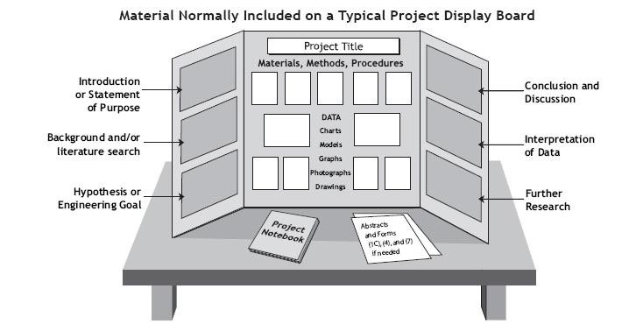

22

How Adults Can Help


- Be a questioner to help achieve focus and clarity. Guide the students rather than lead. Encourage students to make their own decisions and use the inquiry approach.

- Be a helper by answering questions on the “how to.” A student might require help remembering how to set up a graph or chart. Show them how but don’t do it for them.

- Be an assistant when students need extra hands. Some tasks are just too difficult to do alone. Help them organize time and information.

- Be a coach for students who need help. Show or remind them how to use information and assist in finding appropriate search tools.

- Be a runner for various materials that the student might need. A student might need materials for the project or to visit a site or interview an expert to enhance their study.

- Be a wise listener when students want to share ideas. Allow the student to discuss progress and show interest in the student’s project.

- Most importantly, be an encourager! Allow students to do their own quality work. Students will perform best if they know they have support from teachers and parents. Let them know how well they are doing and how proud you are of their accomplishments.

23

Grades 6-12 SCIENCE FAIR Rubric Descriptors for
Judging SCIENCE Projects
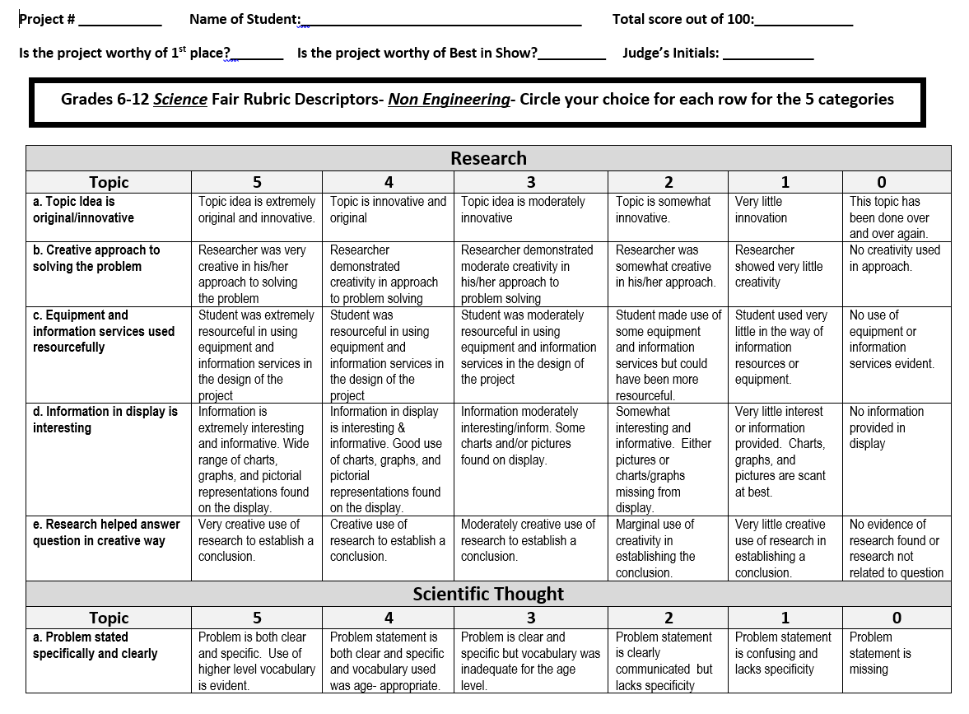

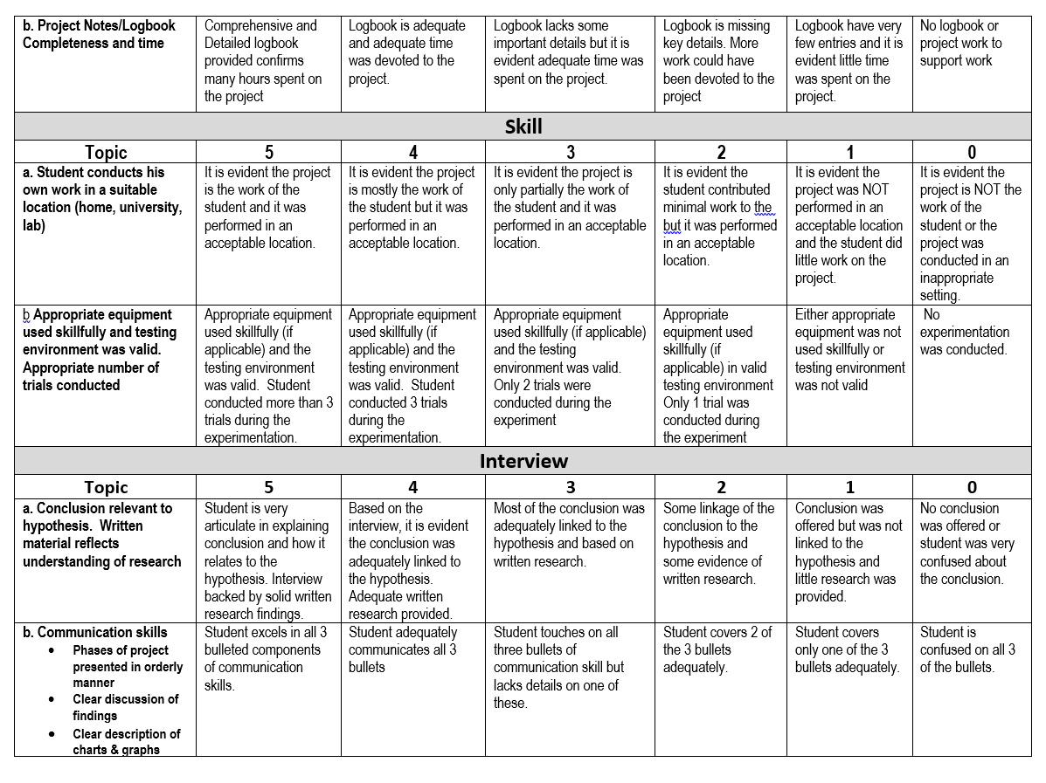

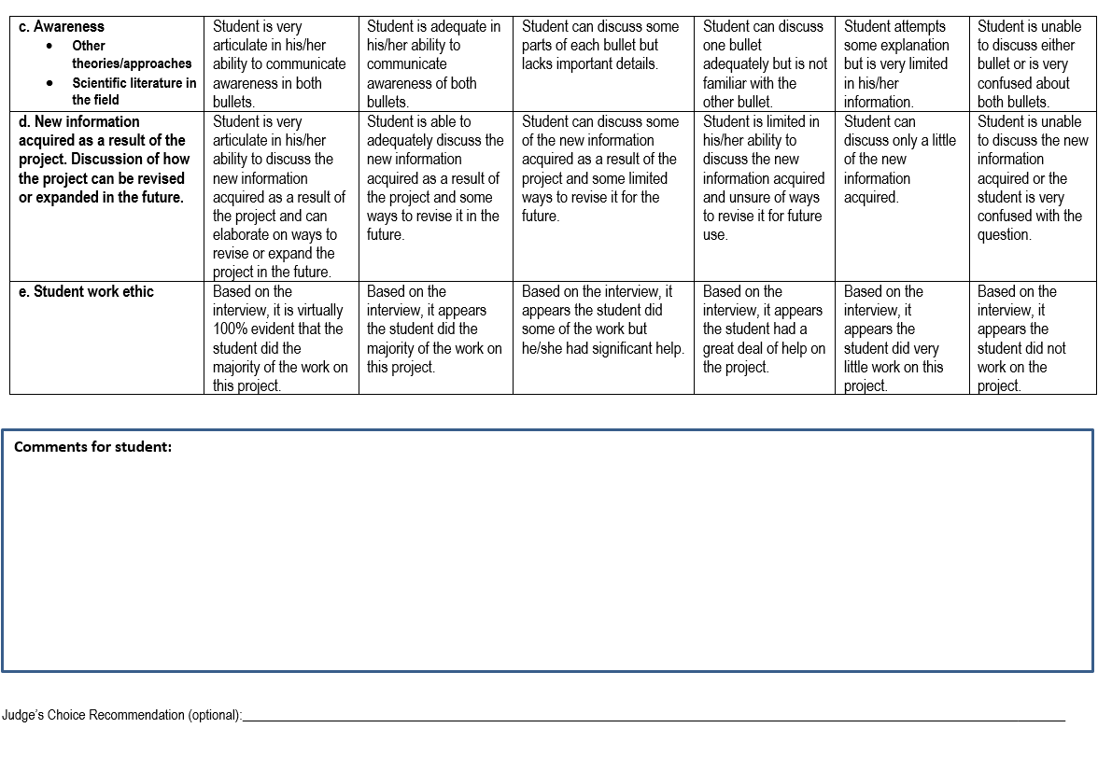

Grades 6-12 Rubric
Descriptors for Judging
Engineering and Computer Science
Projects

